COINS-Xian-Bosporus-Panticapaeum and Chersonesos

48 results [Save this search](https://www.ebay.com/sch/alexkarev80/m.html?item=163045526950&hash=item25f6454da6%3Ag%3AX1UAAOSw8nxbArcK&rt=nc&_trksid=p2047675.l2562#save)

Top of Form

Bottom of Form

[Guaranteed 3 day delivery](https://www.ebay.com/sch/alexkarev80/m.html?item=163045526950&hash=item25f6454da6%3Ag%3AX1UAAOSw8nxbArcK&rt=nc&_trksid=p2047675.l2562)

**Items in search results**

* [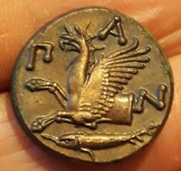](https://www.ebay.com/itm/Pantikapaion-Bosporos-Pan-Satyr-Griffin-N-AE20-NICE-COIN/163033693195?hash=item25f590bc0b:g:gOsAAOSwRNRbAsUM)

[**Pantikapaion Bosporos Pan Satyr Griffin ПАN AE20 NICE COIN**](https://www.ebay.com/itm/Pantikapaion-Bosporos-Pan-Satyr-Griffin-N-AE20-NICE-COIN/163033693195?hash=item25f590bc0b:g:gOsAAOSwRNRbAsUM)

* + $460.00
  + or Best Offer
  + +$10.00 shipping
  + From Estonia
* [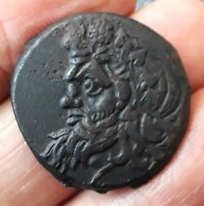](https://www.ebay.com/itm/Pantikapaion-Bosporos-Pan-Satyr-Bow-and-Arrow-NTI-AE27-NICE-COIN/163057888586?hash=item25f701ed4a:g:TRYAAOSwt5VbArKp)

[**Pantikapaion Bosporos Pan Satyr Bow and Arrow ПАNTI AE27 NICE COIN**](https://www.ebay.com/itm/Pantikapaion-Bosporos-Pan-Satyr-Bow-and-Arrow-NTI-AE27-NICE-COIN/163057888586?hash=item25f701ed4a:g:TRYAAOSwt5VbArKp)

* + $195.00
  + or Best Offer
  + +$10.00 shipping
  + From Estonia
* [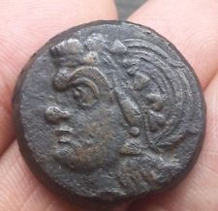](https://www.ebay.com/itm/Pantikapaion-Bosporos-Pan-Satyr-Ox-Head-N-AE28-NICE-COIN/163057890930?hash=item25f701f672:g:4EsAAOSw3uFbArBk)

[**Pantikapaion Bosporos Pan Satyr Ox Head ПАN AE28 NICE COIN**](https://www.ebay.com/itm/Pantikapaion-Bosporos-Pan-Satyr-Ox-Head-N-AE28-NICE-COIN/163057890930?hash=item25f701f672:g:4EsAAOSw3uFbArBk)

* + $220.00
  + or Best Offer
  + +$10.00 shipping
  + From Estonia
* [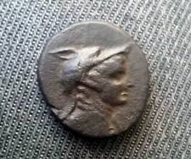](https://www.ebay.com/itm/Pontos-Amisos-AE-Time-of-Mithradates-VI-Amazon-Wolf-Nike-AE22-NICE-COIN/163057890932?hash=item25f701f674:g:M4IAAOSwVgZZulnH)

[**Pontos Amisos AE Time of Mithradates VI Amazon Wolf Nike AE22 NICE COIN**](https://www.ebay.com/itm/Pontos-Amisos-AE-Time-of-Mithradates-VI-Amazon-Wolf-Nike-AE22-NICE-COIN/163057890932?hash=item25f701f674:g:M4IAAOSwVgZZulnH)

* + $220.00
  + or Best Offer
  + Free Shipping
  + From Estonia
* [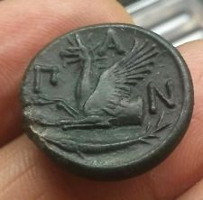](https://www.ebay.com/itm/Pantikapaion-Bosporos-Pan-Satyr-Griffin-N-AE22-NICE-COIN/163057890935?hash=item25f701f677:g:fsQAAOSwEARbArEv)

[**Pantikapaion Bosporos Pan Satyr Griffin ПАN AE22 NICE COIN**](https://www.ebay.com/itm/Pantikapaion-Bosporos-Pan-Satyr-Griffin-N-AE22-NICE-COIN/163057890935?hash=item25f701f677:g:fsQAAOSwEARbArEv)

* + $180.00
  + or Best Offer
  + +$10.00 shipping
  + From Estonia
* [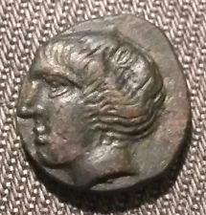](https://www.ebay.com/itm/Theodoseia-Bosporos-EO-O-AE14-Theodosia-Early-polis-issue-Bull-RRR-NICE-COIN/163057890937?hash=item25f701f679:g:cNEAAOSwPHxbArG5)

[**Theodoseia Bosporos ΘEOΔOΣ AE14 Theodosia Early polis issue Bull RRR NICE COIN**](https://www.ebay.com/itm/Theodoseia-Bosporos-EO-O-AE14-Theodosia-Early-polis-issue-Bull-RRR-NICE-COIN/163057890937?hash=item25f701f679:g:cNEAAOSwPHxbArG5)

* + $430.00
  + or Best Offer
  + +$10.00 shipping
  + From Estonia
* [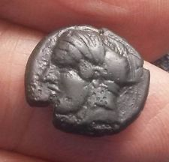](https://www.ebay.com/itm/Tauric-Chersonesos-Artemis-Parthenos-Tunny-Fish-and-Club-First-Issue-AE15-RR/163057892629?hash=item25f701fd15:g:064AAOSwhIZbAq8f)

[**Tauric Chersonesos Artemis Parthenos Tunny Fish and Club First Issue ХЕР AE15 RR**](https://www.ebay.com/itm/Tauric-Chersonesos-Artemis-Parthenos-Tunny-Fish-and-Club-First-Issue-AE15-RR/163057892629?hash=item25f701fd15:g:064AAOSwhIZbAq8f)

* + $255.00
  + or Best Offer
  + Free Shipping
  + From Estonia
* [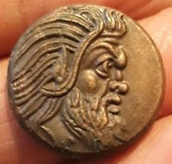](https://www.ebay.com/itm/Pantikapaion-Bosporos-Pan-Satyr-Griffin-N-AE21-NICE-COIN/163033693204?hash=item25f590bc14:g:tMAAAOSwvmNbAsR1)

[**Pantikapaion Bosporos Pan Satyr Griffin ПАN AE21 NICE COIN**](https://www.ebay.com/itm/Pantikapaion-Bosporos-Pan-Satyr-Griffin-N-AE21-NICE-COIN/163033693204?hash=item25f590bc14:g:tMAAAOSwvmNbAsR1)

* + $360.00
  + or Best Offer
  + +$10.00 shipping
  + From Estonia
* [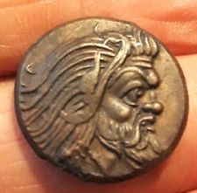](https://www.ebay.com/itm/Pantikapaion-Bosporos-Pan-Satyr-Griffin-N-AE22-NICE-COIN/163045529324?hash=item25f64556ec:g:EvgAAOSwxuhbAsa7)

[**Pantikapaion Bosporos Pan Satyr Griffin ПАN AE22 NICE COIN**](https://www.ebay.com/itm/Pantikapaion-Bosporos-Pan-Satyr-Griffin-N-AE22-NICE-COIN/163045529324?hash=item25f64556ec:g:EvgAAOSwxuhbAsa7)

* + $230.00
  + or Best Offer
  + +$10.00 shipping
  + From Estonia
* [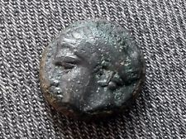](https://www.ebay.com/itm/Tauric-Chersonesos-Artemis-Parthenos-Tunny-Fish-and-Club-First-Issue-AE14-RR/163033693183?hash=item25f590bbff:g:iGQAAOSwMvtZV-iD)

[**Tauric Chersonesos Artemis Parthenos Tunny Fish and Club First Issue ХЕР AE14 RR**](https://www.ebay.com/itm/Tauric-Chersonesos-Artemis-Parthenos-Tunny-Fish-and-Club-First-Issue-AE14-RR/163033693183?hash=item25f590bbff:g:iGQAAOSwMvtZV-iD)

* + $220.00
  + or Best Offer
  + Free Shipping
  + From Estonia
* [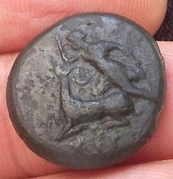](https://www.ebay.com/itm/Tauric-Chersonesos-Artemis-Parthenos-Stag-Bull-K-EMYTA-A-AE21-NICE-COIN/163033693207?hash=item25f590bc17:g:5KcAAOSwVuNbAr~T)

[**Tauric Chersonesos Artemis Parthenos Stag Bull ХЕР KΛEMYTAΔA AE21 NICE COIN**](https://www.ebay.com/itm/Tauric-Chersonesos-Artemis-Parthenos-Stag-Bull-K-EMYTA-A-AE21-NICE-COIN/163033693207?hash=item25f590bc17:g:5KcAAOSwVuNbAr~T)

* + $127.00
  + or Best Offer
  + +$10.00 shipping
  + From Estonia
* [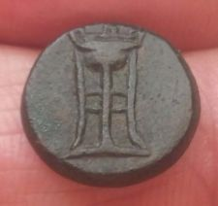](https://www.ebay.com/itm/Pantikapaion-Bosporos-Dichalkon-Star-Tripod-NTIKA-AITON-AE15-NICE-COIN/163057890934?hash=item25f701f676:g:t9YAAOSwCJxaM9To)

[**Pantikapaion Bosporos Dichalkon Star Tripod ПАNTIKAПAITON AE15 NICE COIN**](https://www.ebay.com/itm/Pantikapaion-Bosporos-Dichalkon-Star-Tripod-NTIKA-AITON-AE15-NICE-COIN/163057890934?hash=item25f701f676:g:t9YAAOSwCJxaM9To)

* + $75.00
  + or Best Offer
  + +$10.00 shipping
  + From Estonia
* [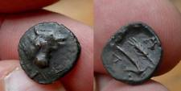](https://www.ebay.com/itm/Pantikapaion-Bosporos-Bull-Plough-Ear-N-AE14/163033693194?hash=item25f590bc0a:g:giQAAOSwdzVXuC~m)

[**Pantikapaion Bosporos Bull Plough Ear ПАN AE14**](https://www.ebay.com/itm/Pantikapaion-Bosporos-Bull-Plough-Ear-N-AE14/163033693194?hash=item25f590bc0a:g:giQAAOSwdzVXuC~m)

* + $80.00
  + or Best Offer
  + +$10.00 shipping
  + From Estonia
* [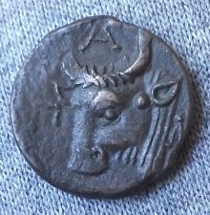](https://www.ebay.com/itm/Pantikapaion-Bosporos-Pan-Satyr-Bulls-head-NTI-AE18-NICE-COIN/163033693202?hash=item25f590bc12:g:sXEAAOSwfLxbArt2)

[**Pantikapaion Bosporos Pan Satyr Bull's head ПАNTI AE18 NICE COIN**](https://www.ebay.com/itm/Pantikapaion-Bosporos-Pan-Satyr-Bulls-head-NTI-AE18-NICE-COIN/163033693202?hash=item25f590bc12:g:sXEAAOSwfLxbArt2)

* + $79.00
  + or Best Offer
  + +$10.00 shipping
  + From Estonia
* [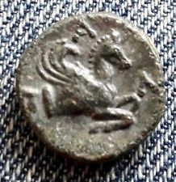](https://www.ebay.com/itm/Pantikapaion-Bosporos-Pan-Satyr-Pegasos-N-AE17-NICE-COIN/163033693205?hash=item25f590bc15:g:NQcAAOSw48dbArp0)

[**Pantikapaion Bosporos Pan Satyr Pegasos ПАN AE17 NICE COIN**](https://www.ebay.com/itm/Pantikapaion-Bosporos-Pan-Satyr-Pegasos-N-AE17-NICE-COIN/163033693205?hash=item25f590bc15:g:NQcAAOSw48dbArp0)

* + $77.00
  + or Best Offer
  + +$10.00 shipping
  + From Estonia
* [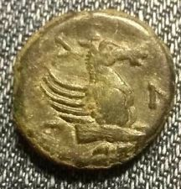](https://www.ebay.com/itm/Pantikapaion-Bosporos-Pan-Satyr-Pegasos-N-AE16-Early-type-NICE-COIN/163045526949?hash=item25f6454da5:g:inoAAOSwFq1bArhK)

[**Pantikapaion Bosporos Pan Satyr Pegasos ПАN AE16 Early type NICE COIN**](https://www.ebay.com/itm/Pantikapaion-Bosporos-Pan-Satyr-Pegasos-N-AE16-Early-type-NICE-COIN/163045526949?hash=item25f6454da5:g:inoAAOSwFq1bArhK)

* + $120.00
  + or Best Offer
  + +$10.00 shipping
  + From Estonia
* [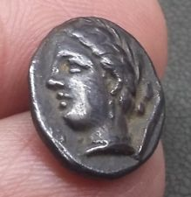](https://www.ebay.com/itm/Thessaly-Pherai-ex-BCD-collection-hemidrachm-triobol-Ennodia-NICE-COIN/163045529323?hash=item25f64556eb:g:cjUAAOSwkcFbArVF)

[**Thessaly Pherai ex BCD collection hemidrachm triobol Ennodia NICE COIN**](https://www.ebay.com/itm/Thessaly-Pherai-ex-BCD-collection-hemidrachm-triobol-Ennodia-NICE-COIN/163045529323?hash=item25f64556eb:g:cjUAAOSwkcFbArVF)

* + $150.00
  + or Best Offer
  + +$10.00 shipping
  + From Estonia
* [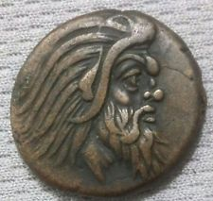](https://www.ebay.com/itm/Pantikapaion-Bosporos-Pan-Satyr-Griffin-N-AE23-NICE-COIN/163045529326?hash=item25f64556ee:g:iU0AAOSw0lVbAsW~)

[**Pantikapaion Bosporos Pan Satyr Griffin ПАN AE23 NICE COIN**](https://www.ebay.com/itm/Pantikapaion-Bosporos-Pan-Satyr-Griffin-N-AE23-NICE-COIN/163045529326?hash=item25f64556ee:g:iU0AAOSw0lVbAsW~)

* + $160.00
  + or Best Offer
  + +$10.00 shipping
  + From Estonia
* [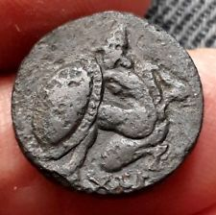](https://www.ebay.com/itm/Tauric-Chersonesos-Artemis-Parthenos-Quadriga-Hoplite-Warrior-AE19-NICE-COIN/163047014153?hash=item25f65bff09:g:snkAAOSwq4lbArOJ)

[**Tauric Chersonesos Artemis Parthenos Quadriga Hoplite Warrior ХЕР AE19 NICE COIN**](https://www.ebay.com/itm/Tauric-Chersonesos-Artemis-Parthenos-Quadriga-Hoplite-Warrior-AE19-NICE-COIN/163047014153?hash=item25f65bff09:g:snkAAOSwq4lbArOJ)

* + $135.00
  + or Best Offer
  + +$10.00 shipping
  + From Estonia
* [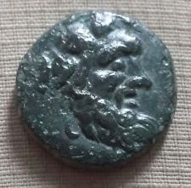](https://www.ebay.com/itm/Phanagoreia-Bosporos-Pan-Satyr-Bow-and-Caduceus-AE14-NICE-COIN/163057876079?hash=item25f701bc6f:g:H6wAAOSwrQxbArMZ)

[**Phanagoreia Bosporos Pan Satyr Bow and Caduceus ФА AE14 NICE COIN**](https://www.ebay.com/itm/Phanagoreia-Bosporos-Pan-Satyr-Bow-and-Caduceus-AE14-NICE-COIN/163057876079?hash=item25f701bc6f:g:H6wAAOSwrQxbArMZ)

* + $89.00
  + or Best Offer
  + +$10.00 shipping
  + From Estonia
* [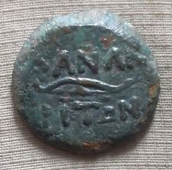](https://www.ebay.com/itm/Phanagoreia-Bosporos-Asander-Portrait-Bow-and-Arrow-NA-OPIT-N-AE18-NICE-COIN/163057890448?hash=item25f701f490:g:GRAAAOSwEwFbArI3)

[**Phanagoreia Bosporos Asander Portrait Bow and Arrow ФАNAГOPITΩN AE18 NICE COIN**](https://www.ebay.com/itm/Phanagoreia-Bosporos-Asander-Portrait-Bow-and-Arrow-NA-OPIT-N-AE18-NICE-COIN/163057890448?hash=item25f701f490:g:GRAAAOSwEwFbArI3)

* + $85.00
  + or Best Offer
  + +$10.00 shipping
  + From Estonia
* [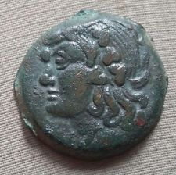](https://www.ebay.com/itm/Pantikapaion-Bosporos-Pan-Satyr-Bow-and-Arrow-N-AE21-NICE-COIN/163057890931?hash=item25f701f673:g:LLEAAOSwT4ZbAq4S)

[**Pantikapaion Bosporos Pan Satyr Bow and Arrow ПАN AE21 NICE COIN**](https://www.ebay.com/itm/Pantikapaion-Bosporos-Pan-Satyr-Bow-and-Arrow-N-AE21-NICE-COIN/163057890931?hash=item25f701f673:g:LLEAAOSwT4ZbAq4S)

* + $75.00
  + or Best Offer
  + +$10.00 shipping
  + From Estonia
* [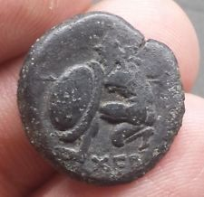](https://www.ebay.com/itm/Tauric-Chersonesos-Artemis-Parthenos-Quadriga-Hoplite-Warrior-AE22-NICE-COIN/163057892628?hash=item25f701fd14:g:4vQAAOSw945bAq6C)

[**Tauric Chersonesos Artemis Parthenos Quadriga Hoplite Warrior ХЕР AE22 NICE COIN**](https://www.ebay.com/itm/Tauric-Chersonesos-Artemis-Parthenos-Quadriga-Hoplite-Warrior-AE22-NICE-COIN/163057892628?hash=item25f701fd14:g:4vQAAOSw945bAq6C)

* + $135.00
  + or Best Offer
  + +$10.00 shipping
  + From Estonia
* [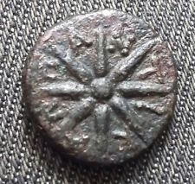](https://www.ebay.com/itm/Pantikapaion-Bosporos-Dichalkon-Star-Tripod-NTIKA-AITON-AE15-NICE-COIN/163033693178?hash=item25f590bbfa:g:UPAAAOSw5PJbAr7U)

[**Pantikapaion Bosporos Dichalkon Star Tripod ПАNTIKAПAITON AE15 NICE COIN**](https://www.ebay.com/itm/Pantikapaion-Bosporos-Dichalkon-Star-Tripod-NTIKA-AITON-AE15-NICE-COIN/163033693178?hash=item25f590bbfa:g:UPAAAOSw5PJbAr7U)

* + $50.00
  + or Best Offer
  + +$10.00 shipping
  + From Estonia
* [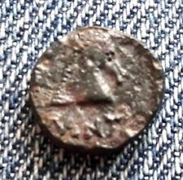](https://www.ebay.com/itm/Pantikapaion-Bosporos-Pan-Satyr-Horse-head-NTI-AE12-RR-NICE-COIN/163033693180?hash=item25f590bbfc:g:iy0AAOSwj0RbAr51)

[**Pantikapaion Bosporos Pan Satyr Horse head ПАNTI AE12 RR NICE COIN**](https://www.ebay.com/itm/Pantikapaion-Bosporos-Pan-Satyr-Horse-head-NTI-AE12-RR-NICE-COIN/163033693180?hash=item25f590bbfc:g:iy0AAOSwj0RbAr51)

* + $35.00
  + or Best Offer
  + +$10.00 shipping
  + From Estonia
* [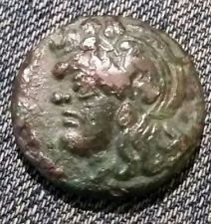](https://www.ebay.com/itm/Pantikapaion-Bosporos-Pan-Satyr-Lion-Fish-N-AE22-NICE-COIN/163033693201?hash=item25f590bc11:g:m5QAAOSwYf9bArnC)

[**Pantikapaion Bosporos Pan Satyr Lion Fish ПАN AE22 NICE COIN**](https://www.ebay.com/itm/Pantikapaion-Bosporos-Pan-Satyr-Lion-Fish-N-AE22-NICE-COIN/163033693201?hash=item25f590bc11:g:m5QAAOSwYf9bArnC)

* + $37.00
  + or Best Offer
  + +$10.00 shipping
  + From Estonia
* [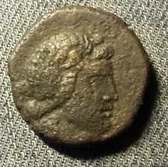](https://www.ebay.com/itm/Pantikapaion-Bosporos-Makhares-Machares-Obol-Pontic-Prince-AE25-NICE-COIN/163045526950?hash=item25f6454da6:g:X1UAAOSw8nxbArcK)

[**Pantikapaion Bosporos Makhares Machares Obol Pontic Prince AE25 NICE COIN**](https://www.ebay.com/itm/Pantikapaion-Bosporos-Makhares-Machares-Obol-Pontic-Prince-AE25-NICE-COIN/163045526950?hash=item25f6454da6:g:X1UAAOSw8nxbArcK)

* + $45.00
  + or Best Offer
  + +$10.00 shipping
  + From Estonia
* [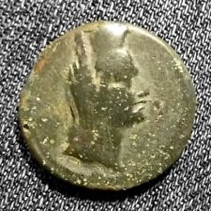](https://www.ebay.com/itm/Pantikapaion-Bosporos-Caesarea-Aphrodite-Scepter-AE21-NICE-COIN/163045526951?hash=item25f6454da7:g:W2AAAOSwX5ZbArak)

[**Pantikapaion Bosporos Caesarea Aphrodite Scepter AE21 NICE COIN**](https://www.ebay.com/itm/Pantikapaion-Bosporos-Caesarea-Aphrodite-Scepter-AE21-NICE-COIN/163045526951?hash=item25f6454da7:g:W2AAAOSwX5ZbArak)

* + $37.00
  + or Best Offer
  + +$10.00 shipping
  + From Estonia
* [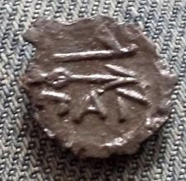](https://www.ebay.com/itm/Pantikapaion-Bosporos-Pan-Satyr-Bow-and-Arrow-N-AE15-NICE-COIN/163045529321?hash=item25f64556e9:g:PegAAOSwKwBbArRk)

[**Pantikapaion Bosporos Pan Satyr Bow and Arrow ПАN AE15 NICE COIN**](https://www.ebay.com/itm/Pantikapaion-Bosporos-Pan-Satyr-Bow-and-Arrow-N-AE15-NICE-COIN/163045529321?hash=item25f64556e9:g:PegAAOSwKwBbArRk)

* + $35.00
  + or Best Offer
  + +$10.00 shipping
  + From Estonia
* [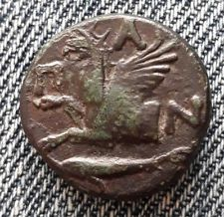](https://www.ebay.com/itm/Pantikapaion-Bosporos-Pan-Satyr-Griffin-N-AE21-NICE-COIN/163047011568?hash=item25f65bf4f0:g:Z7UAAOSwuHJbArP1)

[**Pantikapaion Bosporos Pan Satyr Griffin ПАN AE21 NICE COIN**](https://www.ebay.com/itm/Pantikapaion-Bosporos-Pan-Satyr-Griffin-N-AE21-NICE-COIN/163047011568?hash=item25f65bf4f0:g:Z7UAAOSwuHJbArP1)

* + $45.00
  + or Best Offer
  + +$10.00 shipping
  + From Estonia
* [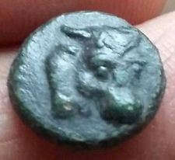](https://www.ebay.com/itm/Pantikapaion-Bosporos-Bull-Plough-Ear-N-AE14-NICE-COIN/163033693188?hash=item25f590bc04:g:qBMAAOSw4aZbAsEV)

[**Pantikapaion Bosporos Bull Plough Ear ПАN AE14 NICE COIN**](https://www.ebay.com/itm/Pantikapaion-Bosporos-Bull-Plough-Ear-N-AE14-NICE-COIN/163033693188?hash=item25f590bc04:g:qBMAAOSw4aZbAsEV)

* + $70.00
  + or Best Offer
  + +$10.00 shipping
  + From Estonia
* [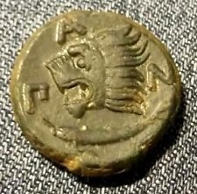](https://www.ebay.com/itm/Pantikapaion-Bosporos-Pan-Satyr-Lion-Fish-N-AE21-NICE-COIN/163045529327?hash=item25f64556ef:g:yUwAAOSw9mFbAriE)

[**Pantikapaion Bosporos Pan Satyr Lion Fish ПАN AE21 NICE COIN**](https://www.ebay.com/itm/Pantikapaion-Bosporos-Pan-Satyr-Lion-Fish-N-AE21-NICE-COIN/163045529327?hash=item25f64556ef:g:yUwAAOSw9mFbAriE)

* + $65.00
  + or Best Offer
  + +$10.00 shipping
  + From Estonia
* [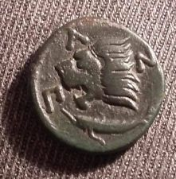](https://www.ebay.com/itm/Pantikapaion-Bosporos-Pan-Satyr-Lion-Head-Sturgeon-Fish-NTI-AE21-NICE-COIN/163057890933?hash=item25f701f675:g:Yf4AAOSwRRZbAq2A)

[**Pantikapaion Bosporos Pan Satyr Lion Head Sturgeon Fish ПАNTI AE21 NICE COIN**](https://www.ebay.com/itm/Pantikapaion-Bosporos-Pan-Satyr-Lion-Head-Sturgeon-Fish-NTI-AE21-NICE-COIN/163057890933?hash=item25f701f675:g:Yf4AAOSwRRZbAq2A)

* + $65.00
  + or Best Offer
  + +$10.00 shipping
  + From Estonia
* [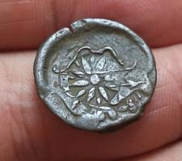](https://www.ebay.com/itm/Pantikapaion-Bosporos-Pan-Satyr-Bow-Arrow-AE20-Overstruck-Countermark-NICE-COIN/163057890936?hash=item25f701f678:g:ufIAAOSwq9tZlq9R)

[**Pantikapaion Bosporos Pan Satyr Bow Arrow AE20 Overstruck Countermark NICE COIN**](https://www.ebay.com/itm/Pantikapaion-Bosporos-Pan-Satyr-Bow-Arrow-AE20-Overstruck-Countermark-NICE-COIN/163057890936?hash=item25f701f678:g:ufIAAOSwq9tZlq9R)

* + $59.00
  + or Best Offer
  + +$10.00 shipping
  + From Estonia
* [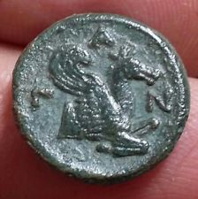](https://www.ebay.com/itm/Pantikapaion-Bosporos-Pan-Satyr-Pegasos-N-AE17-NICE-COIN/163057892028?hash=item25f701fabc:g:saYAAOSwm4NbAq~v)

[**Pantikapaion Bosporos Pan Satyr Pegasos ПАN AE17 NICE COIN**](https://www.ebay.com/itm/Pantikapaion-Bosporos-Pan-Satyr-Pegasos-N-AE17-NICE-COIN/163057892028?hash=item25f701fabc:g:saYAAOSwm4NbAq~v)

* + $70.00
  + or Best Offer
  + +$10.00 shipping
  + From Estonia
* [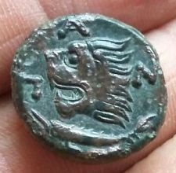](https://www.ebay.com/itm/Pantikapaion-Bosporos-Pan-Satyr-Lion-Fish-N-AE21-NICE-COIN/163033693192?hash=item25f590bc08:g:PD4AAOSw0cJbAsDA)

[**Pantikapaion Bosporos Pan Satyr Lion Fish ПАN AE21 NICE COIN**](https://www.ebay.com/itm/Pantikapaion-Bosporos-Pan-Satyr-Lion-Fish-N-AE21-NICE-COIN/163033693192?hash=item25f590bc08:g:PD4AAOSw0cJbAsDA)

* + $40.00
  + or Best Offer
  + +$10.00 shipping
  + From Estonia
* [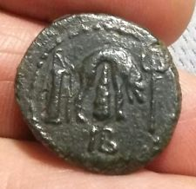](https://www.ebay.com/itm/Bosporos-Mithradates-III-Lion-skin-AD-39-AE23-NICE-COIN/163045529322?hash=item25f64556ea:g:EsgAAOSwgcVbArTH)

[**Bosporos Mithradates III Lion skin AD 39 AE23 NICE COIN**](https://www.ebay.com/itm/Bosporos-Mithradates-III-Lion-skin-AD-39-AE23-NICE-COIN/163045529322?hash=item25f64556ea:g:EsgAAOSwgcVbArTH)

* + $77.00
  + or Best Offer
  + +$10.00 shipping
  + From Estonia
* [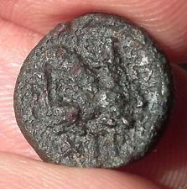](https://www.ebay.com/itm/Tauric-Chersonesos-Hera-and-Zeus-Janiform-Lion-attacking-bull-AE16-NICE-COIN/163033693193?hash=item25f590bc09:g:ATcAAOSw0GNbAsBc)

[**Tauric Chersonesos Hera and Zeus Janiform Lion attacking bull ХЕР AE16 NICE COIN**](https://www.ebay.com/itm/Tauric-Chersonesos-Hera-and-Zeus-Janiform-Lion-attacking-bull-AE16-NICE-COIN/163033693193?hash=item25f590bc09:g:ATcAAOSw0GNbAsBc)

* + $35.00
  + or Best Offer
  + +$10.00 shipping
  + From Estonia
* [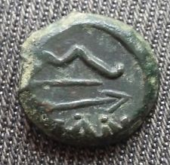](https://www.ebay.com/itm/Pantikapaion-Bosporos-Pan-Satyr-Bow-and-Arrow-NTI-AE17-NICE-COIN/163033693198?hash=item25f590bc0e:g:a98AAOSwuHJbArXc)

[**Pantikapaion Bosporos Pan Satyr Bow and Arrow ПАNTI AE17 NICE COIN**](https://www.ebay.com/itm/Pantikapaion-Bosporos-Pan-Satyr-Bow-and-Arrow-NTI-AE17-NICE-COIN/163033693198?hash=item25f590bc0e:g:a98AAOSwuHJbArXc)

* + $47.00
  + or Best Offer
  + +$10.00 shipping
  + From Estonia
* [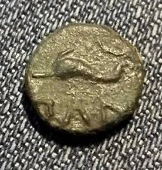](https://www.ebay.com/itm/Pantikapaion-Bosporos-Apollo-Dolphin-N-AE11-Rare-NICE-COIN/163033693184?hash=item25f590bc00:g:kLYAAOSwm8NbArzV)

[**Pantikapaion Bosporos Apollo Dolphin ПАN AE11 Rare NICE COIN**](https://www.ebay.com/itm/Pantikapaion-Bosporos-Apollo-Dolphin-N-AE11-Rare-NICE-COIN/163033693184?hash=item25f590bc00:g:kLYAAOSwm8NbArzV)

* + $50.00
  + or Best Offer
  + +$10.00 shipping
  + From Estonia
* [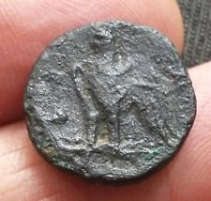](https://www.ebay.com/itm/Egypt-Hellenistic-Ptolemy-I-Soter-Alexandria-AE-Alexander-the-Great-NICE-COIN/163033693177?hash=item25f590bbf9:g:KOUAAOSwzDBbAr84)

[**Egypt Hellenistic Ptolemy I Soter Alexandria AE Alexander the Great NICE COIN**](https://www.ebay.com/itm/Egypt-Hellenistic-Ptolemy-I-Soter-Alexandria-AE-Alexander-the-Great-NICE-COIN/163033693177?hash=item25f590bbf9:g:KOUAAOSwzDBbAr84)

* + $25.00
  + or Best Offer
  + +$10.00 shipping
  + From Estonia
* [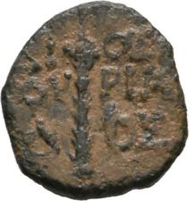](https://www.ebay.com/itm/Colchis-Dioskourias-Kolchis-AE12-Thyrsos/163045529325?hash=item25f64556ed:g:4EsAAOSwCJxaBe9D)

[**Colchis Dioskourias Kolchis AE12 Thyrsos**](https://www.ebay.com/itm/Colchis-Dioskourias-Kolchis-AE12-Thyrsos/163045529325?hash=item25f64556ed:g:4EsAAOSwCJxaBe9D)

* + $27.00
  + or Best Offer
  + +$10.00 shipping
  + From Estonia
* [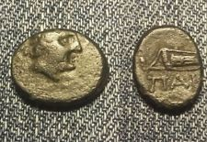](https://www.ebay.com/itm/Pantikapaion-Bosporos-Dichalkon-Apollo-Bow-Gorytos-N-AE14-NICE-COIN/163057892027?hash=item25f701fabb:g:B9cAAOSwf7JbAq-B)

[**Pantikapaion Bosporos Dichalkon Apollo Bow Gorytos ПАN AE14 NICE COIN**](https://www.ebay.com/itm/Pantikapaion-Bosporos-Dichalkon-Apollo-Bow-Gorytos-N-AE14-NICE-COIN/163057892027?hash=item25f701fabb:g:B9cAAOSwf7JbAq-B)

* + $20.00
  + or Best Offer
  + +$10.00 shipping
  + From Estonia
* [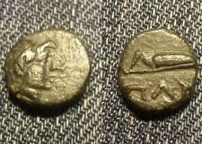](https://www.ebay.com/itm/Pantikapaion-Bosporos-Dichalkon-Apollo-Bow-Gorytos-N-AE12-NICE-COIN/163033693200?hash=item25f590bc10:g:7iEAAOSweltbArlj)

[**Pantikapaion Bosporos Dichalkon Apollo Bow Gorytos ПАN AE12 NICE COIN**](https://www.ebay.com/itm/Pantikapaion-Bosporos-Dichalkon-Apollo-Bow-Gorytos-N-AE12-NICE-COIN/163033693200?hash=item25f590bc10:g:7iEAAOSweltbArlj)

* + $20.00
  + or Best Offer
  + +$10.00 shipping
  + From Estonia
* [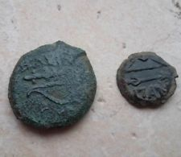](https://www.ebay.com/itm/Lot-of-2-coins-of-Pantikapaion-Bosporos-AE-NICE-COINS/163033693181?hash=item25f590bbfd:g:qukAAOSwJotbAr3T)

[**Lot of 2 coins of Pantikapaion. Bosporos AE NICE COINS**](https://www.ebay.com/itm/Lot-of-2-coins-of-Pantikapaion-Bosporos-AE-NICE-COINS/163033693181?hash=item25f590bbfd:g:qukAAOSwJotbAr3T)

* + $20.00
  + or Best Offer
  + +$10.00 shipping
  + From Estonia
* [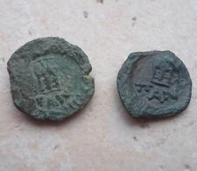](https://www.ebay.com/itm/Lot-of-2-coins-of-Pantikapaion-Bosporos-AE-NICE-COINS/163033693197?hash=item25f590bc0d:g:H6cAAOSwNA1bArYd)

[**Lot of 2 coins of Pantikapaion. Bosporos AE NICE COINS**](https://www.ebay.com/itm/Lot-of-2-coins-of-Pantikapaion-Bosporos-AE-NICE-COINS/163033693197?hash=item25f590bc0d:g:H6cAAOSwNA1bArYd)

* + $25.00
  + or Best Offer
  + +$10.00 shipping
  + From Estonia
* [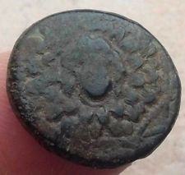](https://www.ebay.com/itm/Pontos-Amisos-AE-Time-of-Mithradates-VI-Aegis-Gorgo-Nike-NICE-COIN/163033693199?hash=item25f590bc0f:g:HekAAOSw945bAsSx)

[**Pontos Amisos AE Time of Mithradates VI Aegis Gorgo Nike NICE COIN**](https://www.ebay.com/itm/Pontos-Amisos-AE-Time-of-Mithradates-VI-Aegis-Gorgo-Nike-NICE-COIN/163033693199?hash=item25f590bc0f:g:HekAAOSw945bAsSx)

* + $17.00
  + or Best Offer
  + +$10.00 shipping
  + From Estonia
* [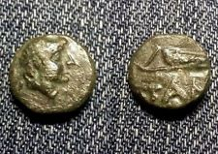](https://www.ebay.com/itm/Pantikapaion-Bosporos-Dichalkon-Apollo-Bow-Gorytos-N-AE12-NICE-COIN/163033693203?hash=item25f590bc13:g:aSoAAOSw8nxbArrm)

[**Pantikapaion Bosporos Dichalkon Apollo Bow Gorytos ПАN AE12 NICE COIN**](https://www.ebay.com/itm/Pantikapaion-Bosporos-Dichalkon-Apollo-Bow-Gorytos-N-AE12-NICE-COIN/163033693203?hash=item25f590bc13:g:aSoAAOSw8nxbArrm)

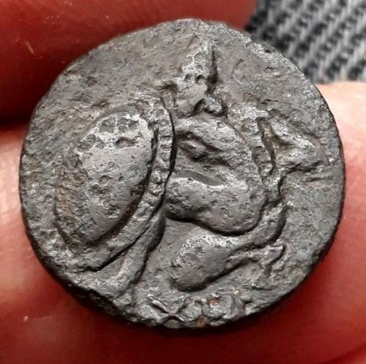

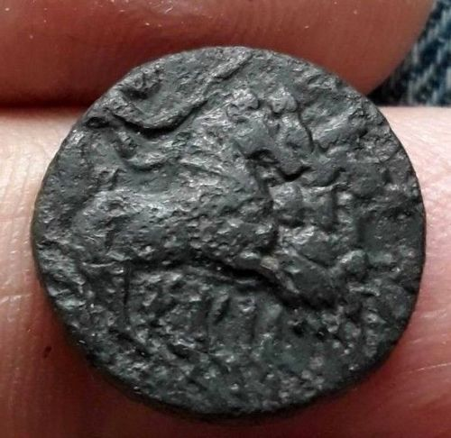

**TAURTAURIC CHERSONESOS, Chersonesos.**Circa 350-300 BC.

AE Dichalkon 19 mm, 4.83 g.

Artemis Parthenos, holding torch and reins, driving fast quadriga right /

Hoplite kneeling left, holding spear in right hand, shield on left arm.; XEP below.

Anokhin (1977) 43; SNG BM Black Sea 738;

**Description**

Tauric Chersonesos, modern Sevastopol', located on the western coast of the Crimea, was founded circa 422 BC by colonists from Herakleia Pontika and Delion in Boiotia. The city quickly rose in stature through its wine production, but also through its location, which was ideal for trade compared to the other cities in the Cimmerian Bosporos. In turn, as the city grew, Chersonesos established a colony at Karkinitis on the northwest coast of the Crimea. In the second century BC, the city became a target of Skythian raids, and it was forced to appeal to Mithridates VI of Pontus for protection. The Pontic king saved the city from the Skythians, but now incorporated Chersonesos into his own dominion. With the passing of Mithridates, the city became a part of the Kingdom of Bosporos, but finally regained its independence by declaration of the Romans in 36 BC. Chersonesos began issuing coinage in the early 4th century BC, and had a robust production that reflected the successful commercial center that it was. Its types are unusually diverse, depicting various gods and mythological creatures, although Athena Parthenos and Chersonas appear most frequently in the Greek and Roman periods, respectively. Initially, the city’s coinage was almost strictly bronze, with only a couple rare issues of silver. By the third century, however, a regular silver coinage began to be produced, comparable in size to that of the bronze. This coinage continued into the Roman period, though at a lower level of production after the 1st century BC. In the late 1st century AD, the city issued an unprecedented gold coinage featuring a diademed and draped bust on the obverse (sometimes with the city ethnic), and the figure of Artemis on the reverse. These coins are also dated, probably a convention copied from the contemporary royal Bosporan coinage. Chersonesos had a robust coinage under the Romans, but, unlike many other cities, its coinage never named any of the emperors. While the reverse types featured a diverse selection of mythological scenes and deities, the obverse typically featured a bust of the eponymous Chersonas accompanied by the city’s ethnic. During the Severan period, there were a few issues where this bust appears to have individualized features resembling particular emperors, such as Caracalla, Elagabalus, and Severus Alexander, but even these issues never named the emperor. The coinage under the Empire continued well into the mid-3rd century AD, ending during the reign of Gallienus.